Wingham Brush public School SCHOOL PLAN 2014
SCHOOL CONTEXT
Wingham is a rural, diverse and productive area of the mid North Coast of New South Wales. The area supports a variety of farming and dairying ventures. There is an environmentally sensitive area attached to the school called Wingham Brush which is a small pocket of rainforest with well-maintained boardwalks and is home to a colony of grey bats. Within the school is an environmental centre which is sometimes used by other schools. The town is situated 12K west of Taree. It has a number of heritage listed buildings.

The school caters for all students from those with outstanding skills and talents to those who need extra support and assistance. There are a number of students who receive integration funding and these students are supported by school learning and support officers who are employed through school funding. Parental involvement is encouraged in all facets of schooling. Wingham Brush School strives to provide the best educational opportunities for its students so that they achieve their potential and have positive feelings of self and community worth.

SCHOOL IDENTIFIED PRIORITY AREA/S | INTENDED OUTCOME/S
Literacy  Numeracy  Aboriginal Education  Preparation for the Australian Curriculum (Mathematics)  Assessment and Reporting | Literacy  More than 30% of Year 3 and year 5 students will be placed in the top two bands of spelling and grammar and punctuation in NAPLAN assessments.  Numeracy  More than 30% of students in year 3 and 5 will be placed in the top two bands in NAPLAN numeracy assessments.  Aboriginal Education  Parents and carers of Aboriginal students will participate in the development of PLPs for students.  Australian Curriculum  Staff are well prepared for the implementation of the Australian Curriculum in mathematics.  Assessment and Reporting  The school will review its procedures for assessment and reporting and use data more effectively to enhance teaching/learning programs and provide focussed reporting of achievement for parents and carers.

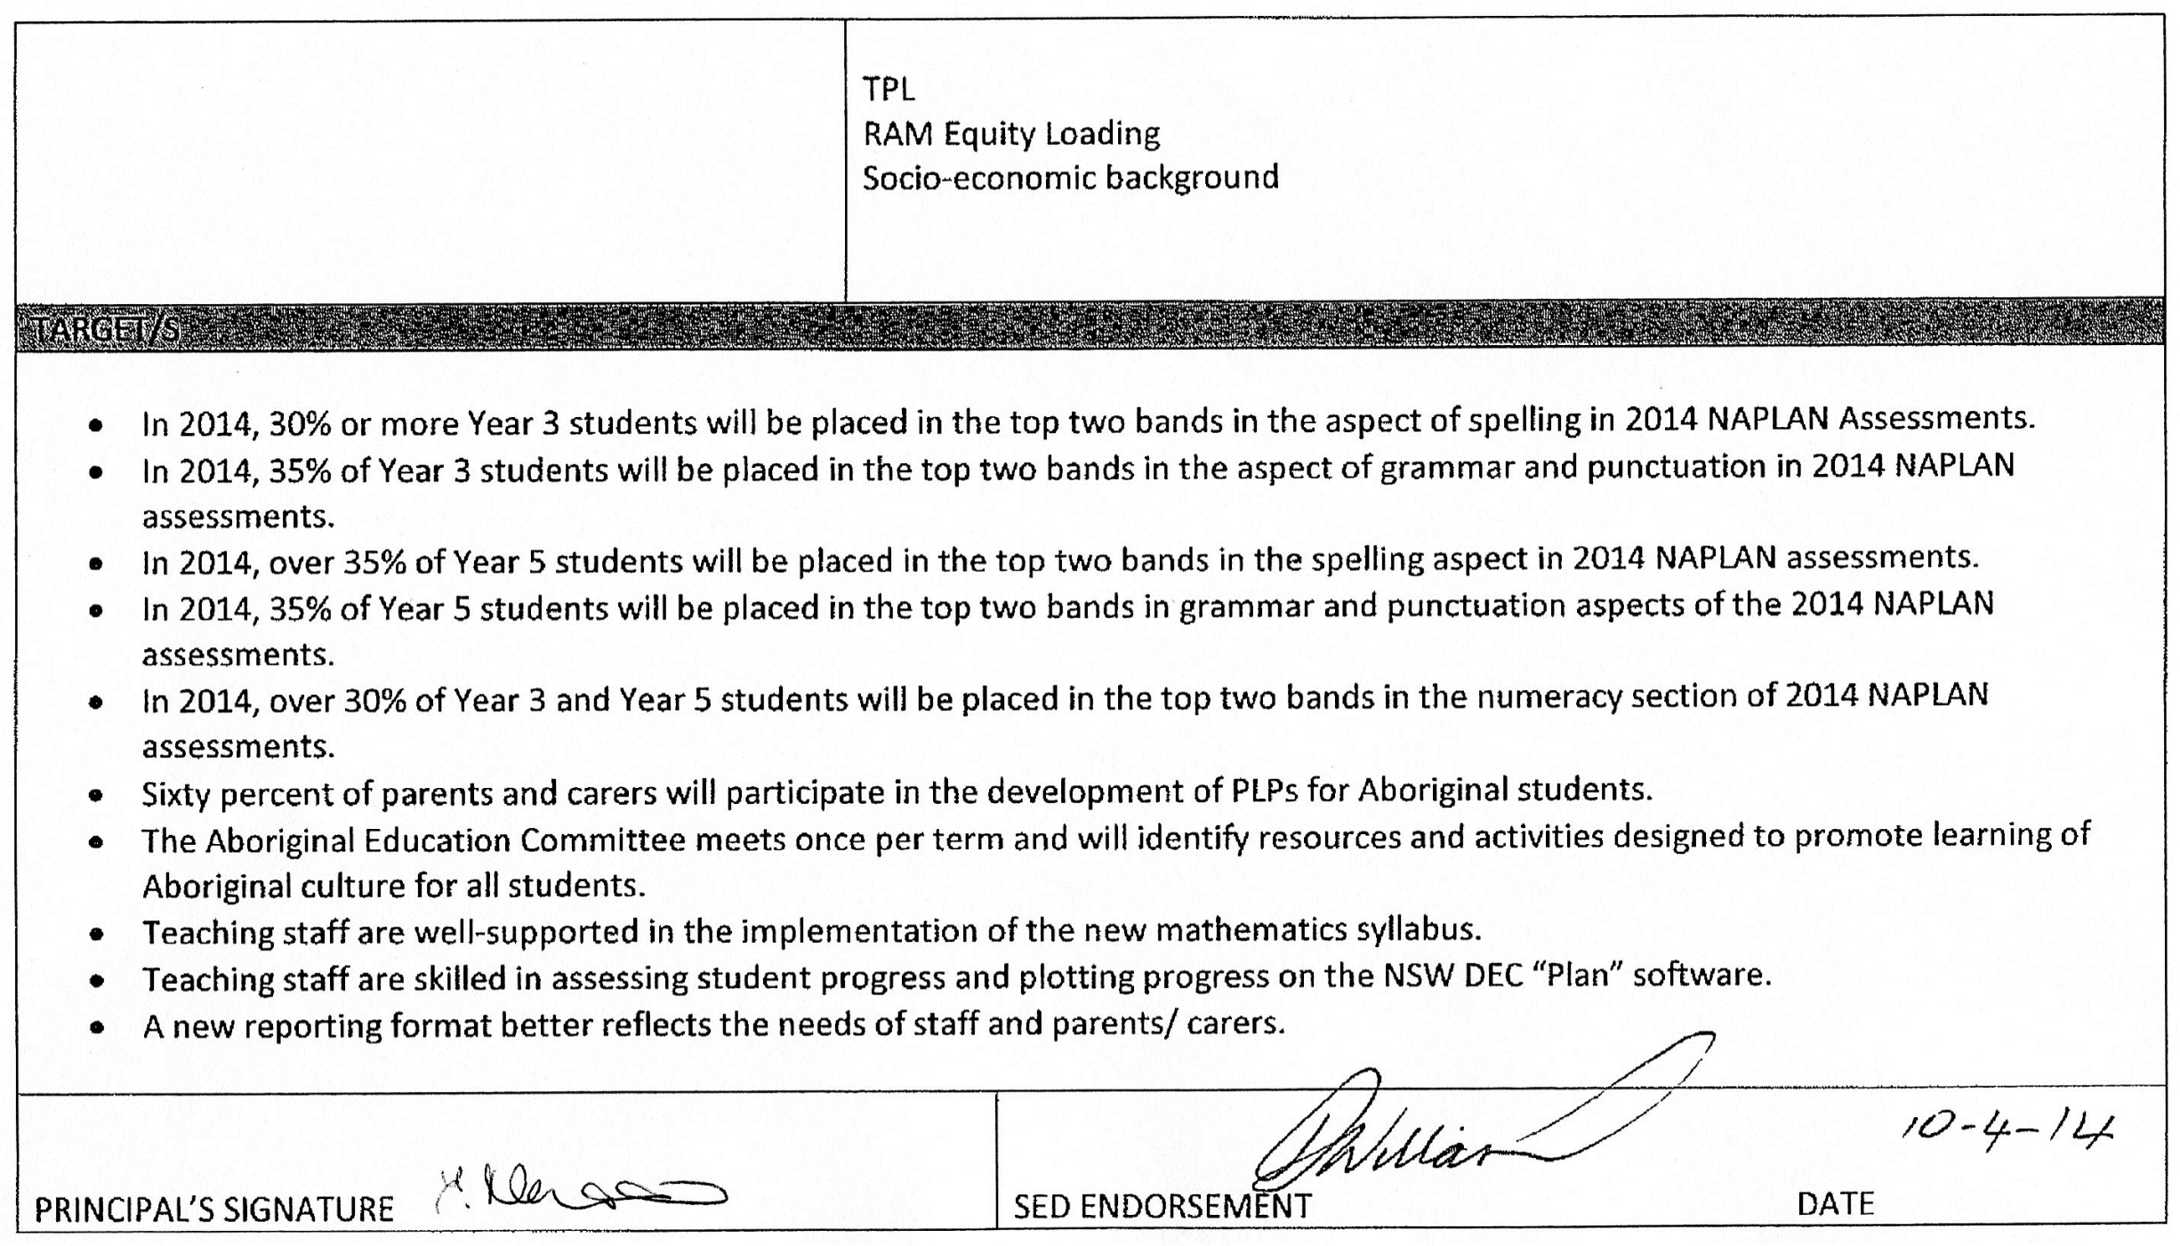

School Identified Priority: Literacy/Numeracy
Strategies | Indicators | Timeframe |  |  |  | Responsibility | Funding/Source  /Budget
Literacy  Spelling/ Grammar and Punctuation  - Implementation of school based spelling and grammar and punctuation scope and sequence developed in 2013.  Reading  - School staff participate in “Focus on Reading” supported by regional personnel.  - Stage 1 staff are trained in L3  Numeracy  - School staff build upon P/L in NinA through participation in ‘Take off with Numeracy” methodology.  - Staff member trained in TOWN  - Engage regional personnel to support implementation of TOWN.  (It is expected that staff P/L in “TOWN” will include implementation strategies for the NSW syllabus for the Australian Curriculum in mathematics.) | Literacy  - Program observations show adherence to school based expectations.  - School based and external spelling assessments show growth.  - NAPLAN results indicate improvement in spelling, grammar and punctuation.  Reading  - Regular professional learning provided by regional support staff.  - Review of implementation through staff/ stage meetings.  - Running records show reading growth across all stages.  - L3 assessment schedule for each student reflects appropriate growth.  Numeracy  - Regular professional learning provided by staff member trained in TOWN  - Program observations reflect directions promoted through TOWN.  - Assessments promoted by TOWN show student growth. | T1  *  *  *  *  *  * | T2  *  *  *  *  * | T3  *  *  *  * | T4  *  *  *  *  *  * | Executive  Classroom teachers  FOR teacher trained in FOR to lead staff in Professional Development  Two Stage 1 staff to complete training in L3 Stage 1  Staff member trained in TOWN program | $1000 - Tied Grants Literacy and Numeracy Programs  $3440 - Tied Grants Literacy and Numeracy Programs  $1500 – Tied Grants Literacy and Numeracy Programs

School Identified Priority: Aboriginal Education
Strategies | Indicators | Timeframe |  |  |  | Responsibility | Funding/Source  /Budget
Aboriginal Education  Personalised Learning Plans  - The Aboriginal Education Committee (AEC) is formed.  - Members of the committee and school staff promote the value of PLPs.  Resources and Cultural Activities  - The AEC reviews current in- school resources for implementation of Aboriginal education.  - The AEC proposes cultural activities which will promote the understanding of Aboriginal culture for all children.  - SLSO employed to support Aboriginal students in classrooms to access specific programs and improve outcomes in reading and numeracy. | Aboriginal Education  - Regular minuted meetings of the AEC.  - Resource identification.  - School participation in NAIDOC/ Sorry Day events.  - Majority participation by parents and carers of Aboriginal students in the development of PLPs.  - Student reports reflect aspects of the developed PLPs.  - NAPLAN Growth data (Reading/Numeracy) for aboriginal students at or better than general school population. | T1  *  *  *  * | T2  *  *  *  * | T3  *  * | T4  *  *  * | Maree Burden/  Charlie Cavanagh  All staff  Maree Burden  Assessment and reporting review committee | Ab Ed Equity ($13000)

School Identified Priority: Curriculum Implementation
Strategies | Indicators | Timeframe |  |  |  | Responsibility | Funding/Source  /Budget
The school prepares for the implementation of the NSW syllabuses for the Australian Curriculum in Mathematics and Science and Technology (2015)  - Staff familiarise themselves with the new syllabus.  - The school reviews current practices.  - The school prepares timelines for implementation.  - Staff engages in professional learning.  - In- School teams engage in professional learning ‘Your School and the New Syllabus’ and ‘Programming and the New Syllabus’.  - Staff meetings, stage meetings and staff development days are used to address the new syllabuses.  Assessment and Reporting  P.L.A.N  - Staff undertake school-based professional learning in the use of PLAN program provided by NSW DEC.  - Staff use PLAN as a tool for tracking assessment and determining student achievement.  Reporting Student Achievement (Reporting Format)  - Teaching staff outline requirements for new report format.  - P&C are consulted about their requirements for student reports.  Reports gathered from other schools. | - Staff members have copies of the new syllabuses.  - All teaching staff access PL courses, “Implementing the New Curriculum”  - Yearly time lines produced for syllabus implementation.  - Staff/ Stage meetings have syllabus implementation as a major focus.  - Community of Schools shared events.  Implementation Timetable  English 2014  Mathematics 2015  Science and Technology 2015  History 2016  Assessment and Reporting  - Staff meeting agenda shows professional learning in on-line data recording.  - Teachers regularly record data on PLAN.  - Supervisors validate data entry of teaching staff.  - Staff meeting discussions reflect staff requirements.  - P&C minutes reflect consultation.  Staff member designated to produce report format. | T1  *  *  *  *  *  *  * | T2  *  *  *  *  *  * | T3  *  *  *  * | T4  *  *  *  *  * | Principal, Executive, Teaching Staff.  Identified staff to lead  All teachers  Executive  Assessment and reporting review committee | Australian Curriculum Implementation  ($1600)
School Identified Priority: Technology
Strategies | Indicators | Timeframe |  |  |  | Responsibility | Funding/Source  /Budget
Addendum to previous School Plan 2013  Funds were allocated to employ a Technology Coach as well as a literacy leader to assist and train teachers in the use of new technologies and preparing a common approach to the teaching and learning in spelling, punctuation and grammar.  Due to the technology coach leaving the school and the literacy leader not using all the funds, some were left over.  We anticipate utilising these funds through the purchase of a colour photocopier with wireless access as well as receipt printers and an EFTPOS machine for these purposes:  - Engagement with the school community.  - Colour newsletter features including School Logo will better engage community members.  - Enhancing communication with the wider community.  - Supporting and ensuring a smooth transition when LMBR is implemented in 2014/15.  - EFTPOS and receipt printers for smooth implementation of LMBR.  - Update of phone system to accommodate EFTPOS line.  - Members of AEC more engaged with communication through the use of colour symbols and icons. | - More community members are aware of what is happening at the school through enhanced  - communication.  - LMBR compatible copier will better facilitate the smooth transition to LMBR.  - AEC role within the school enhanced – more community participation.  - Office staff can support students successfully when implementing LMBR. | T1  *  * | T2  *  *  * | T3  *  *  * | T4  *  *  *  * | Principal, Executive Staff, Office staff | $16000 residual LOW SES (2013) school held NP Funds.

